标题：Forgetful Consumers and Consumption Tracking
作者及机构:
Ying Bao: Gies College of Business, University of Illinois at Urbana-Champaign, Champaign, Illinois 61820
Peter Landry: Department of Management, University of Toronto, Mississauga, Ontario L5L 1C6, Canada
Mengze Shi: Department of Marketing, HKUST Business School, Hong Kong
摘要: We study the market consequences of advances in consumption tracking technologies—such as mobile banking apps that help consumers monitor their spending and avoid overdrawn accounts—using a two-period consumption model. In the model, consumers pay a penalty fee if they consume in both periods. In the second period, consumers may be forgetful of their first-period consumption, although the use of consumption tracking can remind them. According to our analysis, the availability of consumption tracking often helps consumers at the expense of the firm; such benefits may bedirect, where consumers make use of the technology to avoid penalty fees, orindirect, where the mere availability of consumption tracking forces the firm to lower its penalty fee. If consumers arepartiallysophisticated regarding their forgetfulness, however, the availability of consumption tracking may instill a false sense of security in that consumersexpectto use consumption tracking to avoid penalty fees but ultimately, decide not to bother, making them especially susceptible to penalty fees. In some cases, the availability of consumption tracking may actually compel a firm to impose a penalty fee that would not otherwise be viable, leading to higher profits and lower consumer surplus. As we show, this scenario is attained within an intermediate range of forgetfulness and at a level of (partial) sophistication for which consumers overestimate their demand for the technology.
AI标题: 消费追踪技术双刃剑效应：基于部分理性消费者的策略性定价模型
AI精炼: 该研究聚焦行为经济学与消费者决策领域，探讨消费追踪技术（如银行APP）如何影响企业与消费者的博弈关系。针对传统市场模型中消费者因遗忘消费记录而频繁支付罚款的问题，作者构建了一个双周期消费模型，引入“部分理性消费者”概念——即消费者虽意识到自身可能遗忘，但低估其程度。研究发现：当技术使用成本较低时，企业可能被迫降低罚款以阻止消费者使用追踪工具；但若消费者处于“中等遗忘+部分理性”区间，技术反而会制造虚假安全感——他们预期会使用技术规避罚款，最终却放弃使用，导致罚款率及企业利润同步上升。这一发现挑战了“技术必然保护消费者”的直觉，揭示了行为偏差如何被企业策略性利用，为监管新兴技术提供了复杂视角。（247字）
关键词:
双周期消费模型
部分理性消费者
监控成本阈值
策略性定价模型
遗忘概率参数
惩罚性定价机制
虚假安全感效应
消费者行为偏差
学术要点: 学术要点 1：部分理性消费者（Partially Sophisticated Consumers） 指消费者在初始阶段低估自身遗忘程度的行为特征，其预期遗忘率（̃𝛼）低于真实遗忘率（α），导致对消费跟踪技术使用意愿的误判。|||
学术要点 2：非计划均衡（Unplanned Equilibrium） 企业通过调整惩罚费用使消费者预期使用跟踪技术（̃𝐷𝜏>0）但实际未使用（𝐷𝜏=0）的市场状态，导致消费者更易触发惩罚费用。|||
学术要点 3：虚假安全感（False Sense of Security） 消费跟踪技术的可获得性导致部分理性消费者放松警惕，预期通过技术规避惩罚但最终未使用，形成"计划谬误"型决策陷阱。|||
学术要点 4：监控成本阈值（Monitoring Cost Threshold） 决定消费者是否使用跟踪技术的临界值𝑘𝜏=𝛼(1−𝛼)𝜙²，反映惩罚费用（𝜙）与遗忘程度（α）对技术采用决策的非线性影响。|||
学术要点 5：不对称遗忘模型（Asymmetric Forgetfulness Model） 仅针对消费行为存在记忆衰减（对节制行为保持完美记忆）的假设框架，区别于传统对称记忆模型的核心创新设计。
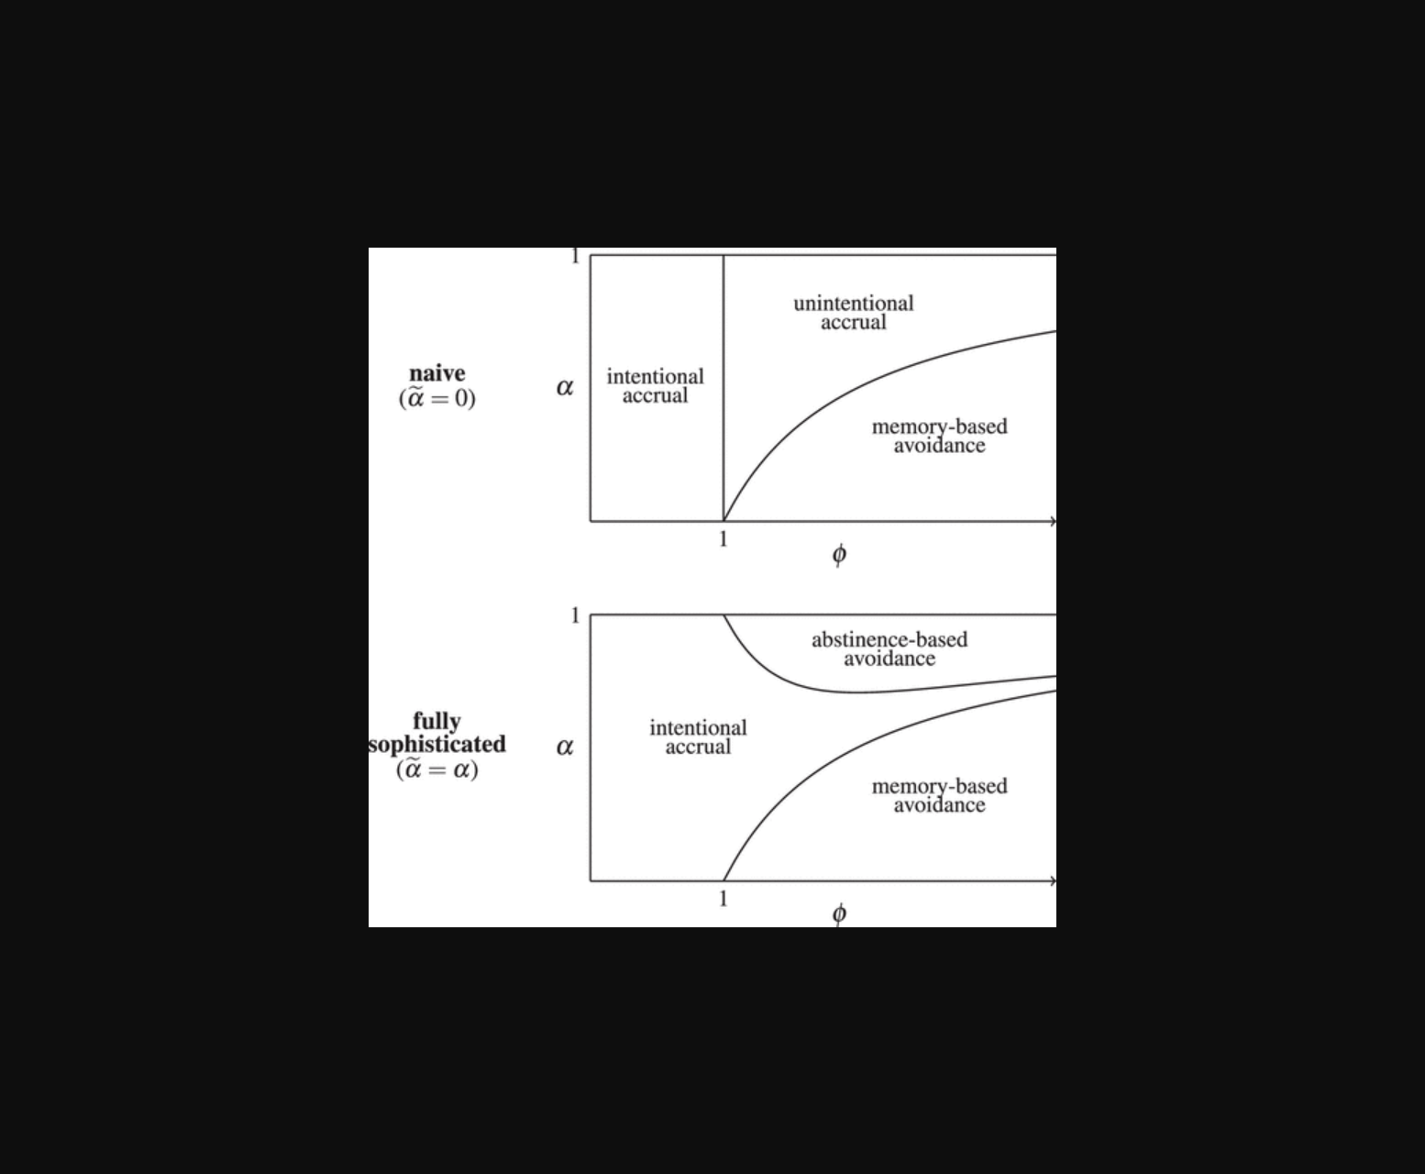
图片展示了不同健忘程度下企业利润与消费者剩余的均衡关系。
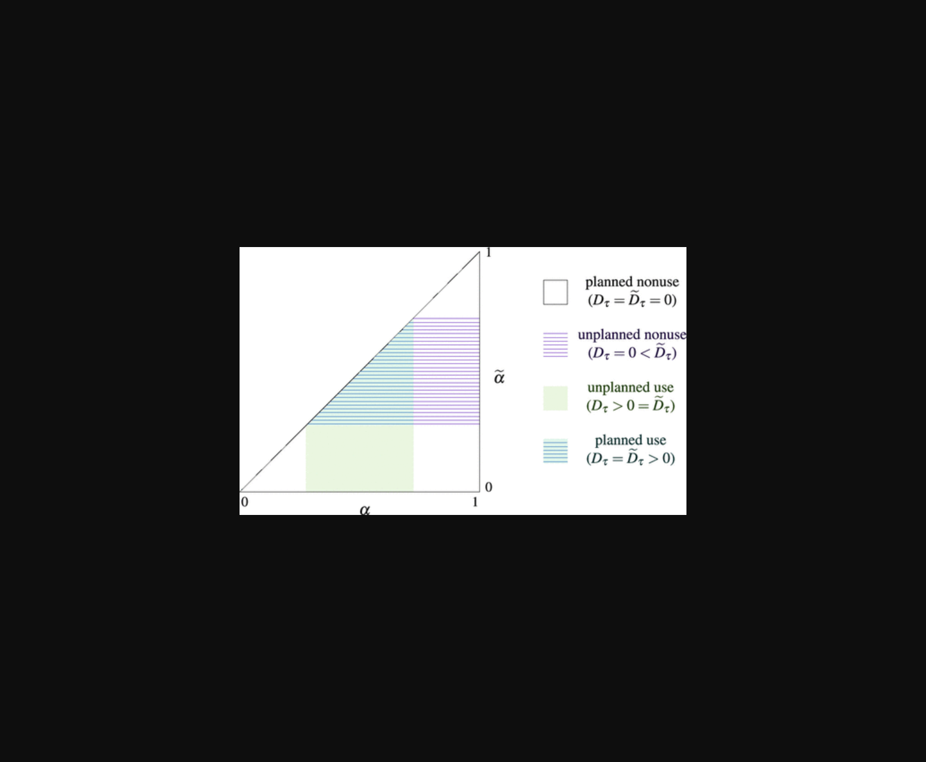
图表展示中间遗忘水平下企业利润与消费者剩余的变化关系。
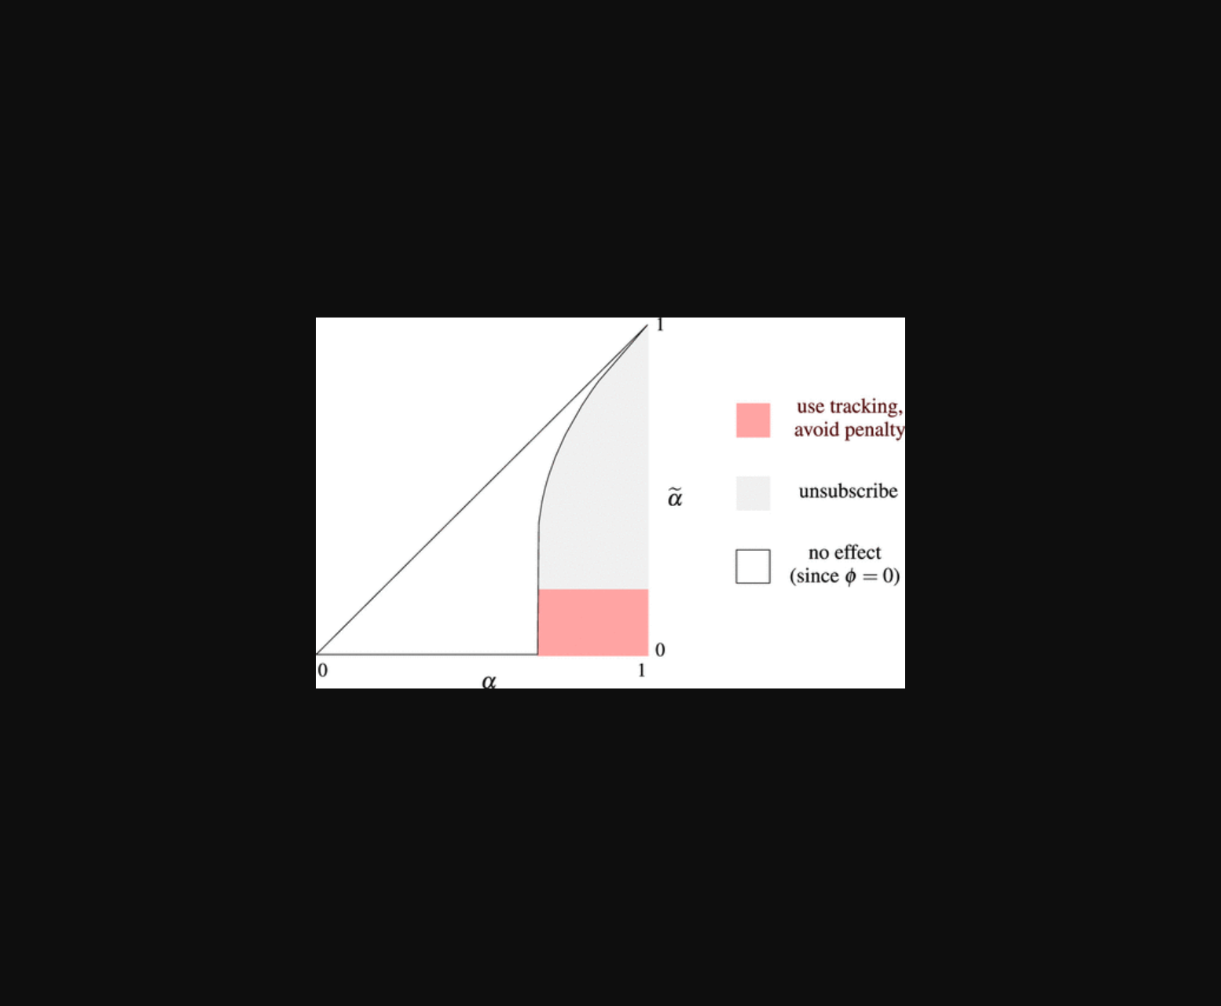
图像展示消费追踪技术可用时企业罚款策略与消费者行为的关系。
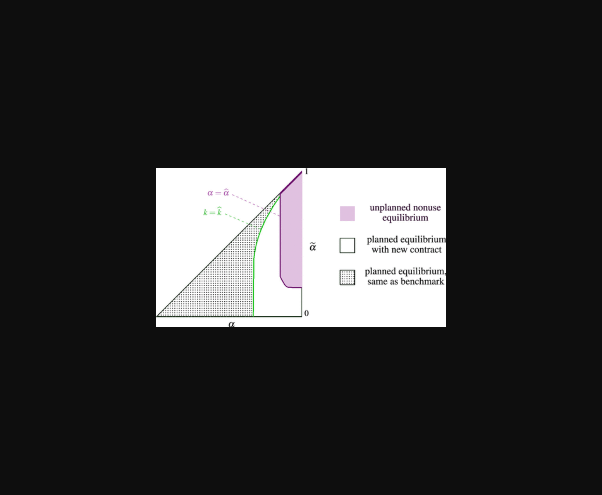
该图呈现了企业利润与消费者剩余随健忘程度和技术采用水平的变化关系。
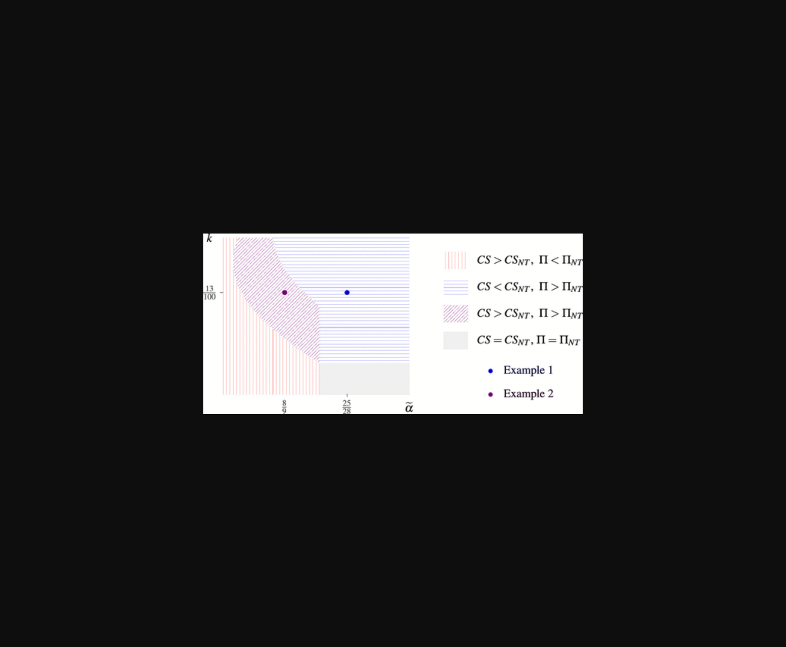
该图呈现了消费者健忘程度与企业最优罚款策略的关联，展示了中间区间内技术反效应。
原文链接: https://doi.org/10.1287/mnsc.2023.00522

